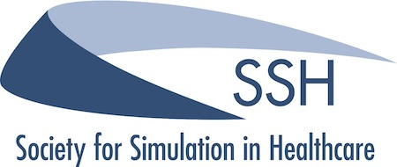

Dear SSH Members,

We’d like to offer heartfelt thanks for your contributions to committees, working groups, and task forces during previous years. We know your time is valuable and consider your service to the Society a tremendous honor. We would like to take this opportunity to invite all members of the Society who have expressed interest in association governance to apply for the open position on the Bylaws Committee. The Bylaws Committee will be compromised of members who represent a spectrum of expertise and experience in healthcare simulation.

Per the SSH bylaws the role of the Bylaws committee is:
“The Bylaws Committee shall be responsible for performing an annual Bylaws review by the end of the first quarter of the fiscal year (September 30th), as required to effectively provide oversight of the Society’s institutional integrity and governance. The Bylaws Committee shall provide recommendations for Bylaws changes and guidance to The Board of Directors for documenting and implementing modifications to the Society’s operational or governance structure.”

If you are interest in becoming a member of the Bylaws Committee, we request that you include a brief, focused CV and a statement of interest (300 words of less), to convey your interest in serving as a committee member. The term of service is three (3) years. Members of the Bylaws committee should plan to attend at least three (3) virtual meetings per year.

Please email any requests, comments or points of clarification to amaxwell@ssih.org.

Our timelines are:
From now: Email questions and submit your documents directly to: amaxwell@ssih.org
August 15: Closing date for submission of interest for the Bylaws committee
August 19: Confirmation of new members

Thank you,
Bonnie Driggers
Chair of the 2016 Bylaws committee

